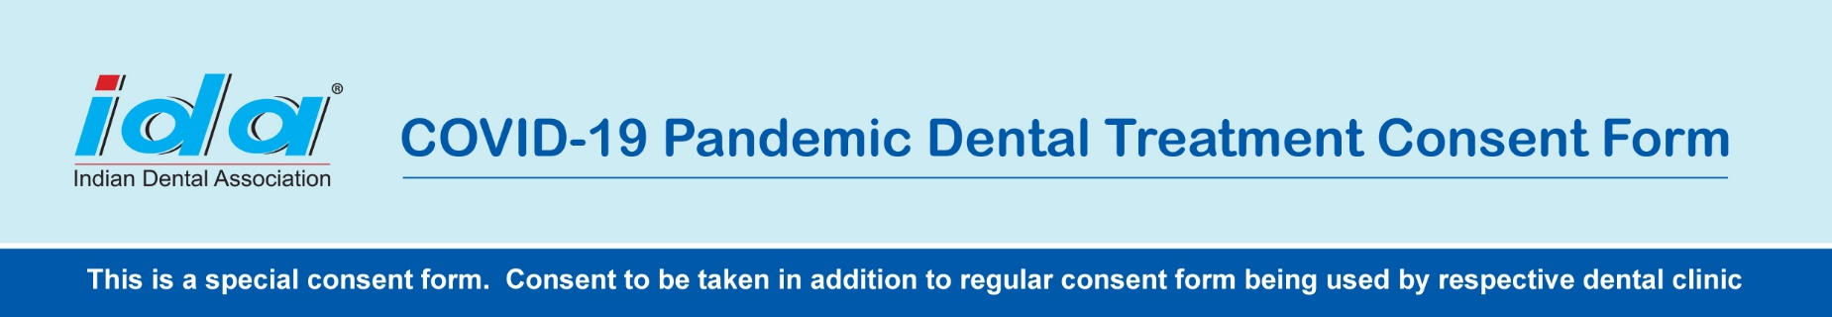

Clinic Name: Enter Clinic Name
Address: _____________________________________________________________________________________
_____________________________________________________________________________________________
I, _______________________________________, knowingly and willingly consent to have dental treatment Completed during the COVID-19 pandemic.
1. I understand the COVID-19 virus has a long incubation period during which carriers of the virus may not show symptoms and still be highly contagious. It is impossible to determine who has it and who does not, given the current limits in virus testing.
2. If I am an asymptomatic carrier or an undiagnosed patient with COVID 19, I suspect it may endanger doctors and clinic staff. It is my responsibility to take appropriate precautions and to follow the protocols prescribed by them.
3. I am aware that I may get an infection from the clinic or from a doctor, and I will take every precaution to prevent this from happening, but I will not at all hold doctors and clinic staff accountable if such infection occurs to me or my accompanying persons.
4. In case I or my attendant get the COVID 19 infection after the visit to the clinic, I will inform the clinic authorities at the earliest, so that appropriate tracking of the patients/attendants and clinic staff present on the day of my visit can be done.
5. I confirm that I am not presenting any of the following symptoms of COVOID-19 listed below:
a – Fever
b – Shortness of Breath
c – Loss of Sense of Taste or Smell
d – Dry Cough
e – Runny Nose
f – Sore Throat
Initials- __________________
6. I understand the government recommends social distancing of at least 6 feet for a period of 14 days to anyone who has shown symptoms or tested positive.
7. I verify that I have not travelled outside of India in the past 14 days to countries that have been affected by COVID-19.
8. I verify that I have not travelled domestic within India by commercial airline, bus, or train within the past 14 days.
9. I verify the information I have provided on this form is truthful and accurate. I knowingly and willingly consent to treatment completed during the COVID-19 pandemic. If I hide my facts and relevant details and because of my knowing or unknowing behaviour or action the clinic staff gets infected, I may be held responsible for appropriate compensation in the court of law.
Name: ____________________________________Sign / Thumb impression: ______________
Date: ____________________

